

A Project Report

On

**“Analytics of Scanned Prescriptions and Notes”**

Batch Details

|  |  |  |
| --- | --- | --- |
| Sl. No. | Roll Number | Student Name |
| 1 | 20201CSE0095 | G RISHIKESH |
| 2 | 20201CSE0120 | MANGAMURI RAMU |
| 3 | 20201CSE0158 | TEJASWINI C |
| 4 | 20201CSE0166 | SAMSON S |

**School of Computer Science,**

**Presidency University, Bengaluru.**

Under the guidance of,

Mr. Ramesh T

School of Computer Science,

Presidency University, Bengaluru

**CONTENTS**

1. Introduction about Project
2. Literature Review
3. Objectives

## Methodology

1. Timeline for Execution of Project
2. Expected Outcomes
3. Conclusion
4. References

**CHAPTER 1**

**INTRODUCTION**

Prescriptions are typically used to communicate the names, dosages, and durations of prescribed or recommended medications for a specific patient by the doctor. Most doctors write prescriptions in a way that is convenient for them, but it is not always easy for patients or others to understand. This is because doctors often have their own unique style of writing prescriptions. Normally, a medical prescription written by a doctor uses common medical terminologies and Latin abbreviations, is usually extremely hard to read and understand for a person who has no prior medical knowledge or background. So, the challenge arises as to how to identify the names of the drugs written in the prescription. A pharmacist may be able to understand the handwriting of the doctor; but a patient may not always.

Apart from that, the way of writing a prescription change from one doctor to another. Fig. 1.1 shows images of some of the various forms of how prescriptions are written.

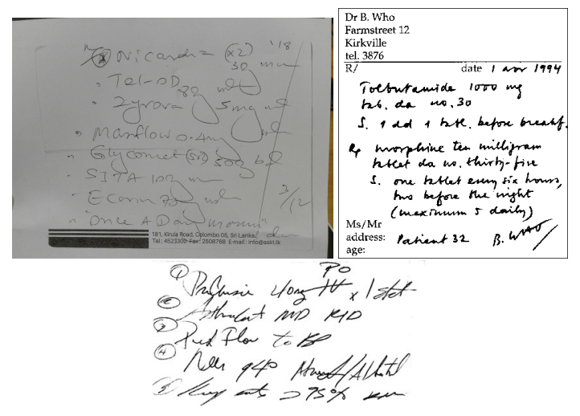

Fig 1.1 Sample Prescriptions describing variety in expression.

Due to these differences in prescription-writing styles, they are prone to misidentification errors. Misinterpreting either the name of the drug, dosage or the duration may lead to some serious problems in the patient’s health condition. This may even lead to deaths. A sample case summary is described below in Fig 1.2

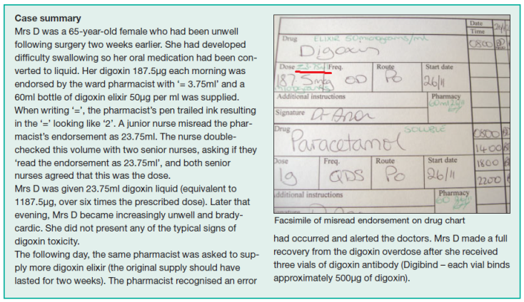

Fig 1.2 Case summary of misinterpretation of dosage

Doctors may use abbreviations while writing prescriptions; which may further increase the confusion in interpreting the dosages of medications prescribed. The Wikipedia article “List of abbreviations used in medical prescriptions” lists this set of abbreviations. In this list, they have also mentioned the possible misreading's.

Because of some similar looking drug names, similar usage directions and dosages, misreading of prescriptions can cause critical health problems, even death.

This paper's primary contribution is the suggestion of a solution system that benefits the patient and the pharmacist by offering a mobile application that can identify and examine the handwriting of the doctor on the prescription and provides a readable digital text that includes the medication's dosage.

*Key Terminologies*: Convolutional Neural Network (CNN), Natural Language Processing (NLP), Optical Character Recognition (OCR), Classification, Machine learning, handwriting recognition.

**CHAPTER 2**

**LITERATURE REVIEW**

Literature on the analytics of scanned prescriptions and notes discusses the application of data analytics in healthcare to improve processes, outcomes, and patient care. Several studies have explored the potential of using analytics to analyze scanned prescriptions and notes for various purposes, including medication reconciliation, adherence monitoring, and personalized medicine.

A survey by Swathi suggested a system that recognizes handwritten medication names from pictures of prescription notes by combining machine learning algorithms and image processing techniques. To enhance the quality of the images, the system first uses preprocessing methods like noise reduction and image subtraction. A convolutional neural network (CNN) is then used to categorize and extract features from the pictures. In order to increase accuracy, the names of the medications are finally identified using optical character recognition (OCR), and the results are then compared to a dataset containing all known medications. According to reports, the system tested actual cases and achieved an accuracy of 70%.

The suggested method aims to assist in identifying handwritten medical prescriptions written by physicians in developing nations, where many physicians are too busy to write digital prescriptions and a large proportion of prescriptions are handwritten and illegible. The suggested method entails creating a dataset of handwritten medical terms and using data augmentation methods to boost the effectiveness of the recognition process. The suggested method yields an average accuracy of 93.0% for handwriting recognition, which is 19.6% higher than the recognition result without data expansion. The handwriting is recognized using a bidirectional long short-term memory (LSTM) network. The suggested technology might be put in a smartpen so that medical professionals could instantly recognize and digitize their handwriting, possibly lowering medical errors and saving lives.

One study by Haas et al. (2017) examined the use of natural language processing (NLP) and machine learning techniques to extract valuable information from scanned prescriptions and clinical notes. The researchers found that these methods could accurately identify medication names, dosages, and frequencies from scanned documents, which could be used to improve medication reconciliation and adherence monitoring.

Another study by Shah et al. (2018) explored the use of analytics to analyze scanned clinical notes for personalized medicine. The researchers developed a system that could extract relevant genetic and clinical information from scanned notes, allowing for the identification of personalized treatment options based on individual patient characteristics.

Furthermore, a study by Kuchta et al. (2019) investigated the use of analytics to analyze scanned prescriptions for medication safety. The researchers developed a system that could identify potentially harmful drug interactions and alert healthcare providers to potential risks based on the information contained in scanned prescriptions.

Overall, the literature on the analytics of scanned prescriptions and notes demonstrates the potential for using data analytics to improve healthcare processes and patient care. These studies highlight the importance of extracting valuable information from scanned documents and leveraging this data to enhance medication reconciliation, adherence monitoring, personalized medicine, and medication safety. As technology continues to advance, the application of analytics in healthcare is likely to play an increasingly important role in improving patient outcomes and reducing healthcare costs.

**CHAPTER 3**

**OBJECTIVES**

Based on the research gaps identified in the literature survey regarding the analytics of scanned prescription and notes, we could consider the following objectives:

1. To develop a machine learning algorithm capable of accurately extracting and interpreting information from scanned prescriptions and notes, aiming to improve the efficiency and accuracy of data entry regarding medication names related to patients in a healthcare system by the hospital in-charges.

2. To investigate the potential of Optical Character Recognition (OCR) and Natural Language Processing (NLP) techniques in analyzing scanned prescriptions and notes to identify patterns, trends, and potential errors in recognizing the medication names, with the goal of enhancing patient safety and reducing the misinterpretation of medication names.

3.To explore the use of data analytics and pattern recognition techniques to identify correlations between medication adherence and patient outcomes based on the information obtained from scanned prescriptions and notes, aiming to improve treatment plan adherence and patient health outcomes, (**if possible**).

4.To assess the feasibility of using scanned prescription and notes analytics with the objective of developing medication name recognizer for pharmacists or patients to enhance prescription-reading accuracy and patient safety.

**CHAPTER 4**

**EXPERIMENTAL DETAILS/METHDOLOGY**

Components to be used during the project:

|  |  |
| --- | --- |
| **Name** | **Description** |
| Flutter | Flutter is an open-source UI software development kit created by Google. It is used to develop applications for Android, iOS, Linux, Mac, Windows, Google Fuchsia, and the web from a single codebase. |
| Cloud Firestore | Cloud Firestore is a flexible, scalable database for mobile, web, and server development by Firebase and Google Cloud. |
| Firebase Storage | Cloud Storage for Firebase is a powerful, simple, and cost-effective object storage service built for Google scale. |
| TensorFlow | TensorFlow is an open-source software library for machine learning.  TensorFlow Lite is a set of tools that enables on-device machine learning by helping developers run their models on mobile, embedded, and IoT devices.  We are going to use TensorFlow Lite for Android during the project. |
| Keras | Keras is an open-source software library that provides a Python interface for artificial neural networks. |
| Open CV | OpenCV is a library of programming functions mainly aimed at real-time computer vision. |
| Android Studio | Android Studio is an Integrated Development Environment (IDE) for developing apps to be run on Google’s Android operating system. |

* The handwritten character recognition model will be trained on the [EMNIST dataset](https://www.kaggle.com/crawford/emnist). The data will be read from a CSV file and converted into numpy arrays without any pre-processing or data augmentation. The properties of the EMNIST dataset are as follows –

1. Number of classes - 47
2. AllClasses 0123456789ABCDEFGHIJKLMNOPQRSTUVWXYZabdefghnqrt
3. Image Size - 28x28x1 ( 28x28 pixel grayscale image)
4. Number of training images - 112,800
5. Number of testing images - 18,800

* The dataset containing medication names for comparison is obtained from kaggle; which is a .csv file named “[A_Z_medicines_dataset_of_India](https://www.kaggle.com/datasets/shudhanshusingh/az-medicine-dataset-of-india)” containing names of 253973 medications along with some of it’s details like price, manufacturer name, composition, etc.

**METHODOLOGY**

**- DESIGN PROCEDURE**

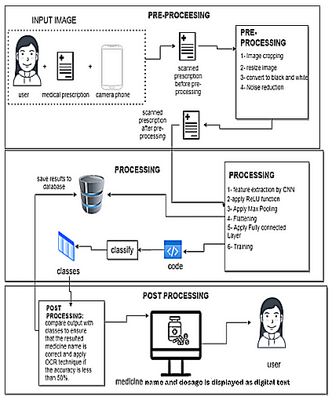

Fig 4.1 Overall process model

The medical prescription will first be scanned by the smartphone camera as suggested in the model, after which it will undergo pre-processing steps such as image subtraction, black-white conversion, noise reduction, and image resizing.

Following that, it will proceed to the processing stage, where a convolutional neural network (CNN) will be used to apply feature extraction and classification for training the obtained data set. Ultimately, during the post-processing stage; the output will be compared with 20% of the gathered dataset. When comparing the results with the data set that includes details of all drugs, the OCR technique is performed to the medications with low accuracy to identify their names.

1. *Pre-processing phase*

In the pre-processing phase, firstly, the scanned prescriptions’ images enter the system as an input using the mobile camera and the extension type of the image is set to PNG. Secondly, the size of the image is normalized by cropping white spaces and converting the image into black and white.

Thirdly, the morphological operation technique is applied on the image to make all the images of the same size based on a comparison of the corresponding pixel in the input image with its neighbors.

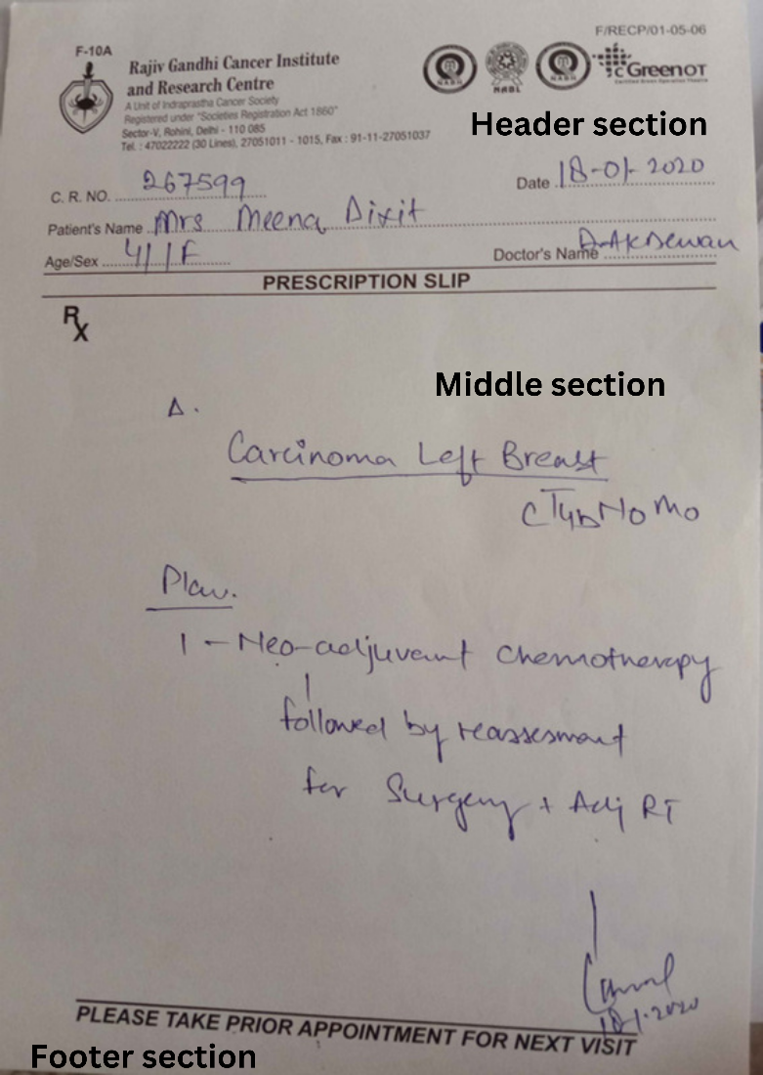

Fig 4.2 Structure of a medical prescription

The first part is from the beginning of the prescription till (R/) symbol which includes the name of the hospital and other header information. The second part, which starts right after the (R/) symbol includes the prescribed medicines, doses, and instructions; which is the most important part during our analysis as the system will identify the medicine and the dose from this part. The third part contains the doctor’s phone numbers and the hospital or doctor’s clinic addresses; which is the least important part.

The patient has to make sure that the image given to the software is cropped properly to the middle section of the prescription.

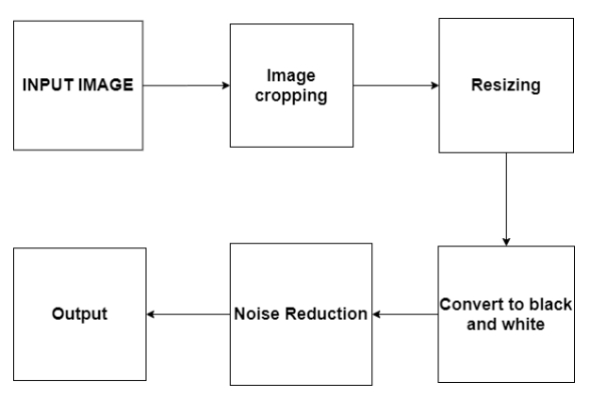

Fig 4.3 Block diagram of pre-processing

*B.Processing phase:*

After the pre-processing phase, the prescribed medication names seen in the middle section of the prescription will be classified using forward and backward propagation technique of the convolutional neural network of the CNN. CNN performs feature extraction and classification on the input image. It consists of multiple layers which are categorized under feature extraction and classification in which the Convolutional layer, ReLu layer, and Maxpooling layer are known as feature extraction techniques that are applied on the input image, and then the fully connected layer is applied for classification and output the image as shown in figure 4.4

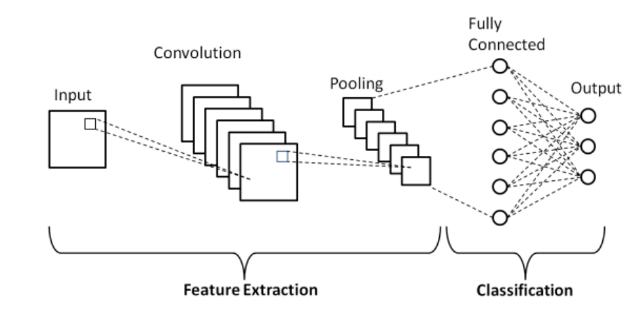

Fig 4.4 CNN Layers

First, we will begin the stage of convolution, which comprises the input image, a feature detector, and a feature map; it is referred to as the feature extraction stage. Later, the filter is taken and applied pixel block by pixel block through the multiplication matrix to the preprocessed middle image, so the feature map is filled or completed. A lot of feature maps are developed to obtain our initial layer of convolution. Second, we are going to use the Sobel operation to develop an edge detection filter. Third, the layer known as the Rectified Linear Unit (ReLU) is another step that serves as an activation function for the Convolution layer, which is applied to increase the non-linearity in the network. Fourth, we employ the maxpooling strategy to attain spatial variance, inorder to gradually reduce the input representation size as it makes it easier to detect and identify objects wherever they are located inside the image. Not only does pooling aid in reducing the amount of processing and the number of parameters required but also, it controls the issue of overfitting. Finally, the pooled feature map is flattened into a sequential long vector to allow the information to enter the input layer in the ANN to be further processed. The above process is summarized in Fig 4.5.

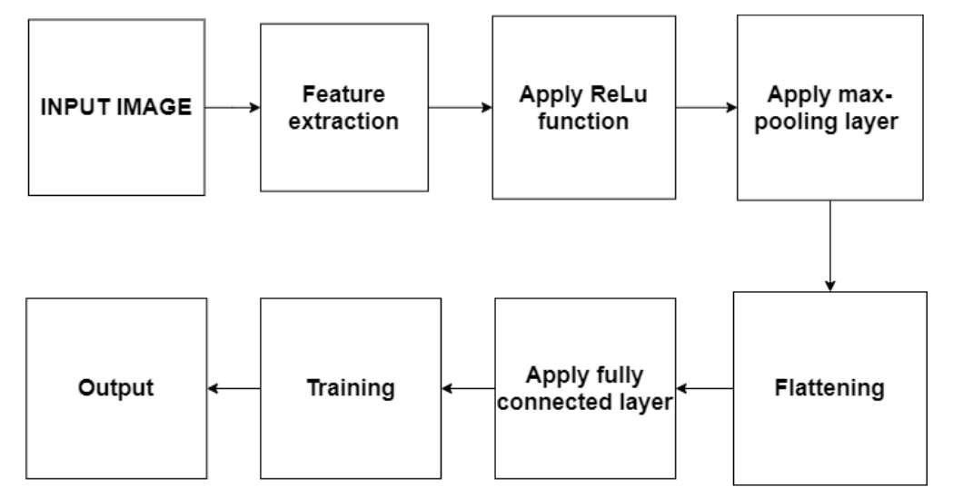

Fig 4.5 Processing diagram

*C.Post-processing*

The character groups obtained are combined to form words. After we get the predicted word (name of the medicine), the result is passed through a matching algorithm. This is done to remove any errors in the prediction. (for example: sometimes the medicine 'crocin' may get predicted as 'crocim') After these errors are removed, we get the full name of the medicine.

Techniques like Optical Character Recognition (OCR) will be applied on the resulted medication name, to recognize character-by-character & then comparing the OCR result with a dataset that contains all the medicine names to recognize which medicine in the dataset is nearest to the result.

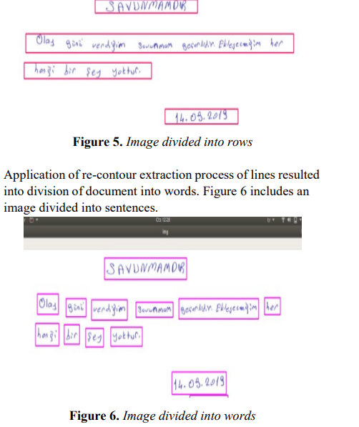

OCR in action

**CHAPTER 5**

**TIMELINE OF THE PROJECT/ PROJECT EXECUTION PLAN**

The project is expected to take 4 months (tentatively) for completion.

|  |  |
| --- | --- |
| **Timeline** | **Events** |
| **Month 1** | Planning about methodology, hardware & software details, modules in the software |
| **Month 2** | Framing the algorithm, writing the code, implementing the backend code (50%) |
| **Month 3** | Finishing the backend code, UI development, checking the code for proper functionality, finishing the report work. |
| **Month 4** | Testing the finished software. |

**CHAPTER 6**

**OUTCOMES**

This paper shows how vital medical prescription recognition is for its significant role in diminishing the problem of misinterpreting medicine names by users and pharmacists. This research came with a solution using machine learning. The system will be trained by various types of handwritings for each medicine to be able to recognize new handwritings for the medicine by using the CNN model as a classifier and feature extractor.

As for the future work, the system will be trained to reach higher accuracy. Moreover, additional classification techniques alongside the OCR in the post processing phase will be used to achieve higher accuracy and precision in identifying the prescribed medicines. Comparing the OCR result with a robust dataset that contains all the medicine names to recognize which medicine in the dataset is nearest to the result.

We also analyzed the possible sources of errors in our approach. About half of the errors generated by our algorithm may be caused by non-standard formatting, such as: Using small fonts in non-standard caption titles or captions, or via images with many redundant operators detected by text extraction tools but it did not appear in the document. The remaining errors may be due to various text block errors, misclassification of text blocks, or failure to correctly segment regions within the prescription.

**CHAPTER 7**

**CONCLUSION**

One major issue that might result in drug errors and adverse effects for patients is the difficulty of reading handwritten medical prescriptions. We have created a smartphone application that applies machine learning techniques to precisely identify the recommended drug and dosage in order to solve this issue. The software is able to give the patient and the pharmacist a readable digital version of the prescription by comparing it with the medical database.

We provided a method for utilizing the document's layout to extract pertinent (handwritten) data from medical prescriptions; i.e, crop until the handwritten part is clearly visible and then upload.

The methodology used in this study makes use of CNN's capacity to extract characteristics from a handwritten character image and accuracy in identifying those features. Since the recognition algorithm might not output the actual drug name, a mapping with a domain knowledge base (a dataset containing medication names and other information about them) is incorporated to improve output accuracy. This way, the outcome would be an actual drug name that is most appropriate for the identified image rather than just a word that was detected. This study uses image processing and neural networks to accurately recognize the content of a medical prescription.

Not only does this increase the precision with which medication is administered, but it also lessens confusion and possible health hazards for the patient. All things considered, the healthcare sector stands to gain a great deal from the application of technology and machine learning to enhance patient safety and satisfaction.

**CHAPTER 8**

**REFERENCES**

* Medical Prescription Recognition using Machine Learning; by Esraa Hassan, Habiba Tarek, Mai Hazem, Shaza Bahnacy, Lobna Shaheen, Walaa H. Elashmwai
* Medical Prescription Identification Solution, by W.R.A.D Wijewardena under the supervision of Prof. N.D. Kodikara
* Medical prescription recognition using Machine Learning – A survey; by Neha Nayak, Prarthana T, Rohit Joshi, Vaibhavi S, Dr Swathi K
* OCR Optical Character Recognition by Line Eikvil
* Machine Printed Text and Handwriting Identification in Noisy Document Images; by Yefeng Zheng, Student Member, IEEE, Huiping Li and David Doermann, Members of IEEE.
* An online cursive handwritten medical words recognition system for busy doctors in developing countries for ensuring efficient healthcare service delivery; by ShairaTabassum, Nuren Abedin, Md Mahmudur Rahman, Md Moshiur Rahman, Mostafa TaufqAhmed, Rafqul Islam & Ashir Ahmed
* Identification of Handwritten Text in Machine Printed Document Images; by Sandipan Banerjee
* Looking Beyond Text: Extracting Figures, Tables and Captions from Computer Science Papers Christopher Clark and Santosh Divvala
* Automatic Indexing of Scanned Documents - a Layout-based Approach; by Daniel Essera, Daniel Schustera, Klemens Muthmanna, Michael Bergerb, Alexander Schilla aTU Dresden, Computer Networks Group, 01062 Dresden, Germany bDocuWare AG, Therese-Giehse-Platz 2, 82110 Germering, Germany